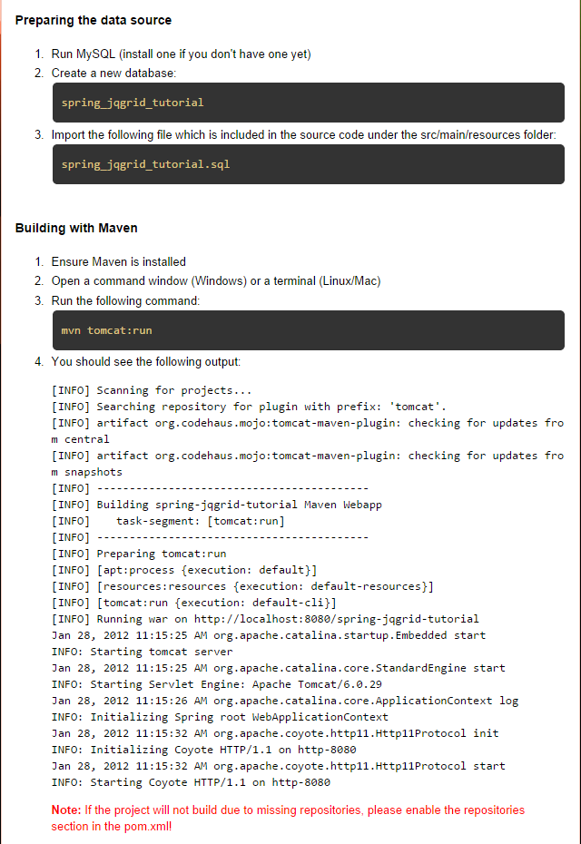

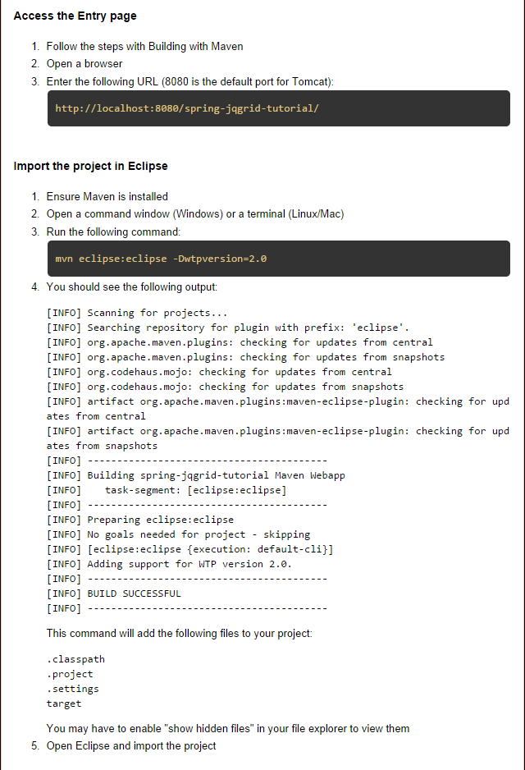

**Additional Notes:**

* I used ‘**admin’** as the MySQL ‘**root’** user password, if you use a different password, you need to change the ‘/spring-jqgrid-tutorial/src/main/webapp/WEB-INF/spring.properties’ file to reflect your selected password.
* When importing the project into eclipse, make sure that you execute the

‘mvn eclipse:eclipse –Dwtpversion=2.0’ in step 3 **BEFORE** importing the project, as it download all the required libraries needed for the eclipse project – **IMPORTANT!**